***Trader Interface Apex.***

**Trader table**

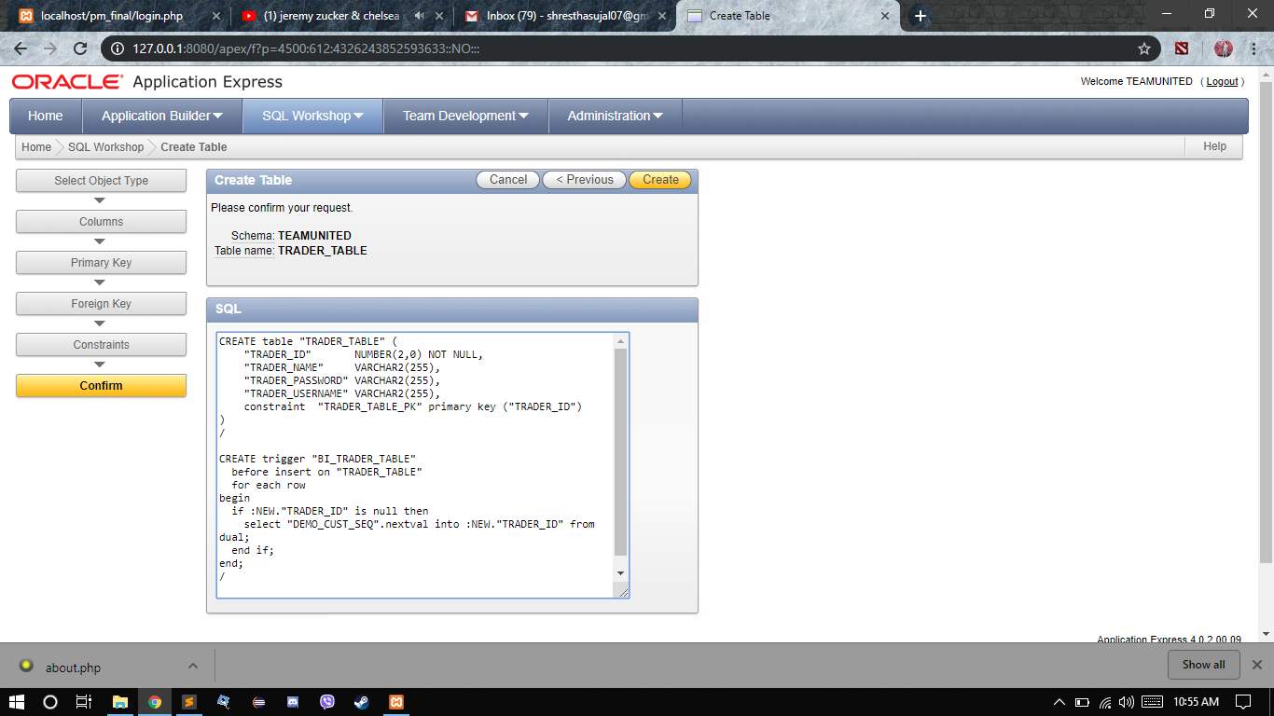

Creating table in oracle for trader with the attributes trader_id, trader_name, trader_password, trader_username and making trader_id as the primary key.

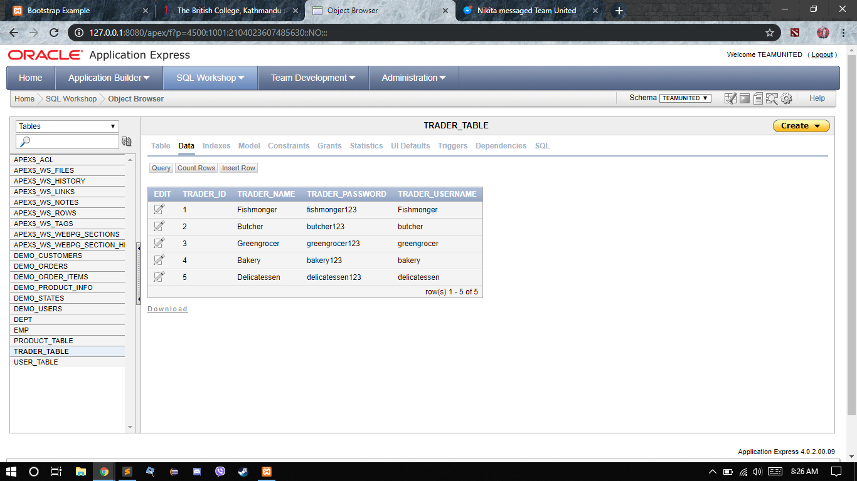

Data entered in traders table.